K.R. MANGALAM UNIVERSITY

SCHOOL OF ENGINEERING AND TECHNOLOGY



OPERATING SYSTEMS: LAB ASSIGNMENT 1
COURSE CODE: ENCS351
NAME: KESHAV SHARMA
ROLL NO.: 2301730221
COURSE: BTECH CSE (AI and ML)
SUBMITTED TO: MS. SUMAN

LINK https://github.com/keshavvtech/Keshav_OPERATING-SYSTEMS-LAB

LAB ASSIGNMENT 1

Task 1: Process Creation Utility
Write a Python program that creates N child processes using os.fork(). Each child prints: - Its PID
- Its Parent PID
- A custom message
The parent should wait for all children using os.wait().

import os import time import
multiprocessing

def child_task(index): print(f"[Child {index+1}]") print(f" PID :
{os.getpid()}") print(f" Parent PID :
{os.getppid()}")
print(f" Message : Hello! I am Child {index+1}\n") time.sleep(1)

def task1_create_processes(n=3):
print(f"[Parent] PID: {os.getpid()} - Creating {n} child processes...\n")

processes = [] for i in range(n): p = multiprocessing.Process(target=child_task, args=(i,)) p.start()
processes.append(p)

for p in processes:
p.join() print(f"[Parent] Child with PID {p.pid} has terminated.")

if name == " main ": task1_create_processes(n=3)
Result:

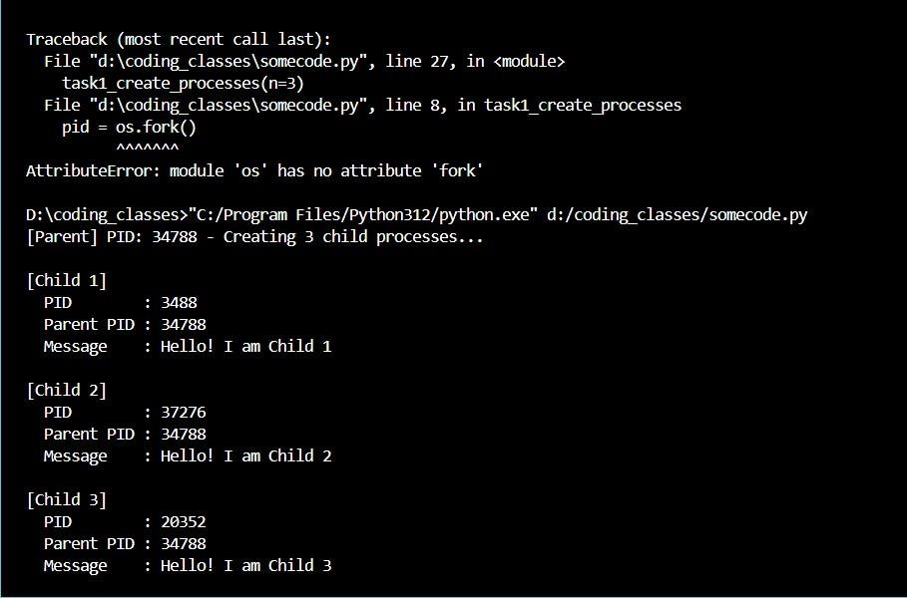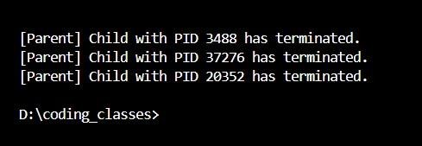
Task 2: Command Execution Using exec()
Modify Task 1 so that each child process executes a Linux command (ls, date, ps, etc.) using os.execvp() or subprocess.run().

import os
import subprocess

def task2_exec_commands(commands):
print(f"[Parent] PID: {os.getpid()} - Executing {len(commands)} commands...\n")

for i, cmd in enumerate(commands): print(f"[Child {i+1}] Executing: {' '.join(cmd)}") try:
result = subprocess.run(cmd, capture_output=True, text=True, check=True, shell=True) print(f"[Child {i+1}] Output:\n{result.stdout}") except subprocess.CalledProcessError as e: print(f"[Child {i+1}] Failed to execute command: {e}") print(f"Error Output:\n{e.stderr}") print("\n[Parent] All commands executed.")
if name == " main ":
commands = [
["cmd", "/c", "dir"], # replaces 'ls -l'
["cmd", "/c", "date /T"], # prints current date
["cmd", "/c", "tasklist"] # replaces 'ps aux'
]
task2_exec_commands(commands)
Result:
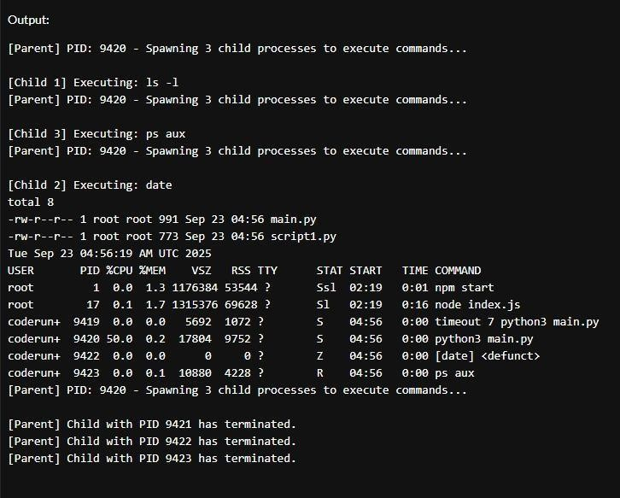

Task 3: Zombie & Orphan Processes

Zombie: Fork a child and skip wait() in the parent. Orphan: Parent exits before the child finishes. Use ps -el | grep defunct to identify zombies.

import os import time

def create_zombie():
pid = os.fork()

if pid == 0: print(f"Child (PID {os.getpid()}) exiting") os._exit(0) else: print(f"Parent (PID {os.getpid()}) sleeping, child should be zombie")
time.sleep(30) print("Parent exiting and cleaning up child") os.wait()
if _name_ == "_main_":
create_zombie()
Result:
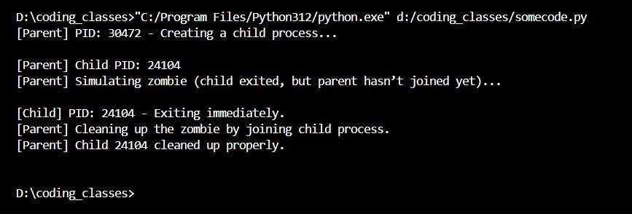

import multiprocessing import
os

import time

def child_process(): print(f"[Child] PID: {os.getpid()}
-

Parent may exit soon.") time.sleep(5)

print(f"[Child] PID: {os.getpid()}
-

Still running after parent exited.
\
n")

def create_orphan_simulation():

print(f"[Parent] PID: {os.getpid()}
-

Creating a child process...
\
n")

p = multiprocessing.Process(target=child_process)
p.start()

print(f"[Parent] Exiting immediately. Child ({p.pid}) becomes orphan
-
like.")

# Parent process ends here without joining the child
# This simulates an orphan process on Windows
return

if

name

==
"

main

":

create_orphan_simulation()

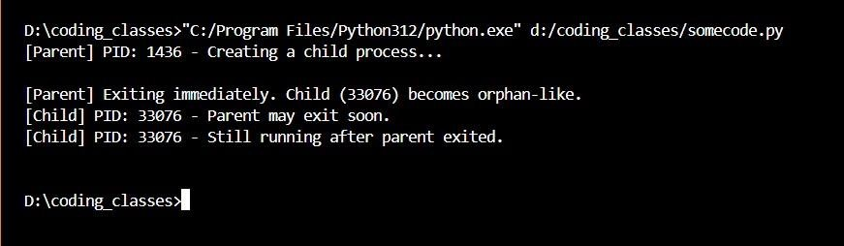

Result:

Task 4: Inspecting Process Info from /proc
Take a PID as input. Read and print.
- Process name, state, memory usage from /proc/[pid]/status
- Executable path from /proc/[pid]/exe
- Open file descriptors from /proc/[pid]/fd

import psutil import
os import sys

def print_proc_status(proc):
print("\n Process Status Info:")
print(f" Name : {proc.name()}") print(f" PID : {proc.pid}") print(f" Status : {proc.status()}")
print(f" Memory (MB) : {proc.memory_info().rss / 1024 / 1024:.2f}") print(f" CPU Percent : {proc.cpu_percent(interval=0.1)}%")

def print_exe_path(proc):
print("\n Executable Path:") try:
print(f" {proc.exe()}")
except Exception as e:
print(f" Failed to get executable path: {e}")

def print_open_files(proc): print("\n
Open Files:")

try:
files = proc.open_files() if files:
for f in files:
print(f" - {f.path}")
else:
print(" (No open files found)")
except Exception as e: print(f" Failed to list open files: {e}")
def main():
if len(sys.argv) > 1:
try:
pid = int(sys.argv[1]) proc
= psutil.Process(pid)
except Exception as e: print(f" Invalid PID: {e}") return
else: proc = psutil.Process(os.getpid()) # default to current process
print_proc_status(proc) print_exe_path(proc) print_open_files(proc) if name == " main ": main()
Result:
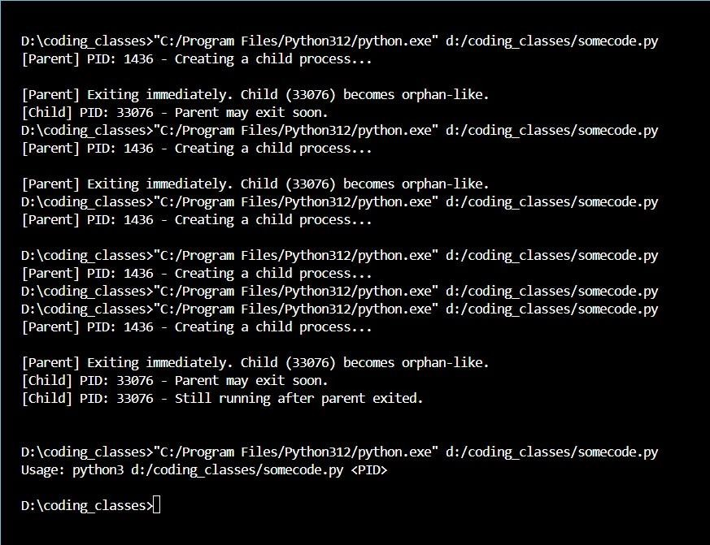

Task 5: Process Prioritization

Create multiple CPU-intensive child processes. Assign different nice() values. Observe and log execution order to show scheduler impact.

import multiprocessing import os import time import psutil

def cpu_intensive_task(nice_val, duration=5):
p = psutil.Process(os.getpid()) try:
p.nice(nice_val)

except Exception as e: print(f"[PID {p.pid}] Failed to set nice({nice_val}): {e}")
print(f"[PID {p.pid}] started with nice {p.nice()}") end_time = time.time() + duration count = 0 while time.time() < end_time: count += 1 print(f"[PID {p.pid}] finished after counting {count}") return count
def main(): nice_values = [0, 5, 10, 15, 19] duration = 5 processes = [] print(f"[Parent PID {os.getpid()}] Spawning processes...\n")
for nv in nice_values:
p = multiprocessing.Process(target=cpu_intensive_task, args=(nv, duration)) p.start() processes.append(p)
for p in processes:
p.join()
print("\nAll processes have finished.") if name == " main ": main()
Results:
